21 Sep 2025
Theme: Certain Hope in the Risen Jesus
[Intro] G G4 G G4 G G4

[Verse 1]
G G4 x3
I serve a risen Savior, He's in the world today;
G F#/D Em A7 D7
I know that He is living, whatever men may say;
G G4 x3
I see His hand of mercy, I hear His voice of cheer,
A7 D
And just the time I need Him, He's al-ways near.

[Chorus]
G G4 G G4 Cadd9 G
He lives, He lives, Christ Jesus lives today!
D7 G A7 He walks with me and talks with me, along
D7
life's narrow way.
G G4 G G4 Cadd9 B
He lives, He lives, Salvation to impart!
E7 A7 G You ask me how I know He lives? He lives
D7 G
within my heart.

[Verse 2]
G G4 x3
In all the world around me I see His loving care,
G F#/D Em A7 D7
And though my heart grows weary I will never despair;

G G4 x3
I know that He is leading through all the stormy blast,
A7 D
The day of His appearing will come at last.

CHORUS

[Verse 3]
G
Rejoice, rejoice O Christian, lift up your voice and sing
G F#/D Em A7 D7
Eternal hallelujahs to Jesus Christ the King!
G
The Hope of all who seek Him, the Help of all who find,
A7 D
None other is so loving, so good and kind.

CHORUS

JESUS REIGNS (minus 2)

[Verse 1]
C Em/B Am
He is the ruler of heaven and earth
Am G F
All of creation declaring his worth
C F C
Hallelujah, Hallelujah

C Em/B Am
Even faraway stars with the faintest of light
Am G F
All bow to the king of the day and the night
C F C
Hallelujah, Hallelujah

[Pre-Chorus]
Am G
Every knee shall bow
F
Every tongue confess
C
All the earth will cry his name.
G
All sing the truth

[Chorus]
Am F
Jesus Reigns!
C G
Jesus Reigns!
Am
So we worship Him
F
We live for him
C G
All honour and praise to his name
F
Yes Jesus Reigns

[Verse 2]
C Em/B Am
He bore our sin, and he took all the blame
Am G F
Died on the cross now forever he reigns
C F C
Hallelujah, Hallelujah

C Em/B Am
The tomb now lies empty, death has no claim
Am G F
The grave overcome, by the Lamb who was slain
C F C
Hallelujah, Hallelujah

[Pre-Chorus]
Am G
Every knee shall bow
F
Every tongue confess
C
All the earth will cry his name.
G
All sing the truth

[Chorus]
Am F
Jesus Reigns!
C G
Jesus Reigns!
Am
So we worship Him
F
We live for him
C G
All honour and praise to his name
F
Yes Jesus Reigns

[Verse 3]
C Em/B Am
Now heaven resounds with a glorious song
Am G F
All glory to Jesus, to Him we belong!
C F C
Hallelujah, Hallelujah

C Em/B Am
The church is his witness, declaring his name
Am G F
With Christ on the throne where forever He'll reign!
C F C
Hallelujah, Hallelujah

[Pre-Chorus]
Am G
And every knee shall bow
F
Every tongue confess
C
All the earth will cry his name.
G
All sing the truth

[Final Chorus]
Am F
Jesus Reigns!
C G
Jesus Reigns!
Am
So we worship Him
F
We live for him
C G
All honour and praise to his name,

Am F
Yes Jesus Reigns!

C G
Jesus Reigns!
Am
So we worship Him
F
We live for him
C G
All honour and praise to his name
F
Yes Jesus Reigns

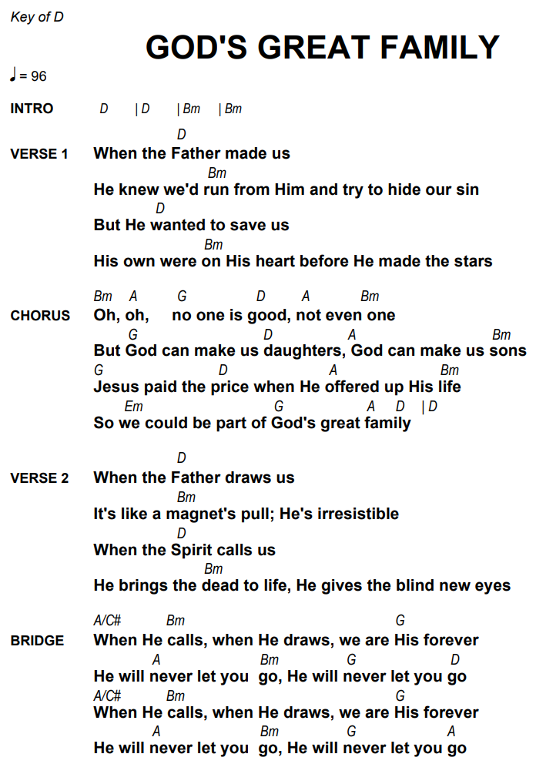
God’s Great Family

In Christ Alone

[Intro]
C G F G C

[Verse 1]
C G
In Christ alone my hope is found
C/E F G C
He is my light my strength my song
G C G
This Cornerstone, this solid Ground
C/E F G C
Firm through the fiercest drought and storm
C/E F Am G
What heights of love, what depths of peace
C/E F Am G
When fears are stilled when strivings cease!
C Am G
My Comforter my All in All
C/E F G C
Here in the love of Christ I stand

[Interlude]
C G F G C

[Verse 2]
C Am G
In Christ alone! Who took on flesh
C/E F G C
Fullness of God in helpless babe!

G C Am G
This Gift of love and righteousness
C/E F G C
Scorned by the ones He came to save
C/E F Am G
Till on that cross as Jesus died
C/E F Am G
The wrath of God was satisfied
C Am G
For every sin on Him was laid
C/E F G C
Here in the death of Christ I live

[Interlude]
C G F G C

[Verse 3]
C Am G
There in the ground His body lay
C/E F G C
Light of the world by darkness slain
G C Am G
Then bursting forth in glorious Day
C/E F G C
Up from the grave He rose again!
C/E F Am G
And as He stands in victory
C/E F Am G
Sin’s curse has lost its grip on me
C Am G
For I am His and He is mine

C/E F G C
Bought with the precious blood of Christ

[Interlude]
C G F G C
A (Transition chord)

[Verse 4]
D Bm A
No guilt in life, no fear in death
D/F# G A D
This is the pow’r of Christ in me
A D Bm A
From life’s first cry to final breath
D/F# G A D
Jesus commands my destiny
[[[
D/F# G Bm A
No pow’r of hell, no scheme of man
D/F# G Bm A
Can ever pluck me from His hand
D Bm A
Till He returns or calls me home
D/F# G A D
Here in the pow’r of Christ I’ll stand
]]] x2
Christ our Hope in Life and Death
[Intro] E Esus E x2

[Verse 1]
E Esus E
What is our hope in life and death?
Esus E C#m B
Christ alone, Christ alone.
E B/D# C#m
What is our only confidence?
A E/B B E
That our souls to Him belong.
G#m C#m
Who holds our days within His hand?
F#m7 E/G# A
What comes, apart from His command?
E B/D# C#m
And what will keep us to the end?
A E/B B E Esus E
The love of Christ, in which we stand.

[Chorus]
C#m (A) E
O sing hallelujah!
B/D# C#m
Our hope springs eternal;
E/G# A E/G#
O sing hallelujah!
A E/G# B A
Now and ever we confess
C#m7 B E Esus E
Christ our hope in life and death.

[Verse 2]
E Esus E
What truth can calm the troubled soul?
Esus E C#m B
God is good, God is good.
E B/D# C#m
Where is His grace and goodness known?

A E/B B E
In our great Redeemer’s blood.
G#m C#m
Who holds our faith when fears arise?
F#m7 E/G# A
Who stands above the stormy trial?
E B/D# C#m
Who sends the waves that bring us nigh
A E/B B E
Unto the shore, the rock of Christ?

[Chorus]
C#m A E
O sing hallelujah!
B/D# C#m
Our hope springs eternal;
E/G# A E/G#
O sing hallelujah!
A E/G# B A
Now and ever we confess
C#m7 B E Esus E
Christ our hope in life and death.

E Esus E x2

[Verse 3]
E Esus E
Unto the grave, what will we sing?
Esus E C#m B
“Christ, He lives; Christ, He lives!”
E B/D# C#m
And what reward will heaven bring?
A E/B B E
Everlasting life with Him.
G#m C#m
There we will rise to meet the Lord,
F#m7 E/G# A
Then sin and death will be destroyed,
E/B G#/C C#m
And we will feast in endless joy,

A E/B B E (hold)
When Christ is ours forevermore.

[Final Chorus]

C#m A E
O sing hallelujah!
B/D# C#m
Our hope springs eternal;
E/G# A E/G#
O sing hallelujah!
A E/G# B A
Now and ever we confess

C#m7 B (E) C#m7
Christ our hope in life and death. (x2)

A E/B E/G# A
Now and ever we confess
C#m7 B/D# E
Christ our hope in life and death.

